Cairo University  
Faculty of Computers and Information



**CS251**

**Software Engineering II**

E-Library

Software Design

Sara ElSheemi – Hagar Gadallah-Youssef Nabil – Tarek Abdalla-Hana Ahmed

11/2016

Contents

Instructions [To be removed] 3

Team 3

Document Purpose and Audience 3

System Models 3

I. System Decomposition 3

II. Class diagrams 6

Important Algorithm 7

III. Sequence diagrams 8

Class - Sequence Usage Table 9

IV. Physical Entity-Relationship Diagram 10

V. User Interface Design 10

VI. Bonus: State Diagram and OCL 12

Ownership Report 12

Policy Regarding Plagiarism: 12

References 12

Authors 12

# Team

|  |  |  |  |
| --- | --- | --- | --- |
| **ID** | **Name** | **Email** | **Mobile** |
| 20146020 | Sara ElSheemi | Saraelsheemi93@yahoo.com |  |
| 20146014 | Hagar Gadallah |  |  |
| 20146015 | Youssef Nabil |  |  |
| 20146010 | Tarek Abdallah |  |  |
|  |  |  |  |

# Document Purpose and Audience

* **Any document should tell the reader 2 things: What is this document? Who is expected to read it?**
* **Write in simple notes: what this document is.**
* **List the target audience to read this document (e.g. CEO? Project Manager? Customer...?)**

# System Models

## I. System Decomposition

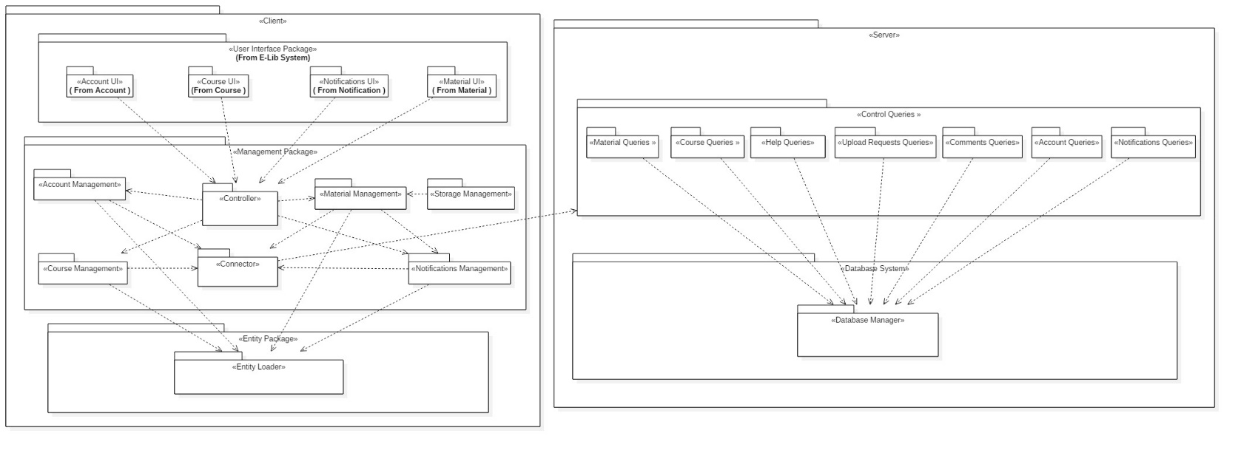

## II. Class diagrams

* **You should provide your class diagram. In case on diagram is so complex, divide it to several ones of reasonable size or draw separate ones, each for one of the components on the system decomposition diagram.**
* **Class diagram is a static diagram and should not represent any dynamic flow of events.**
* **Put stereotypes of the classes to give more information. UML predefines some stereotypes like: <<interface>>, <<type>>, <<implementationClass>>, <<enumeration>>, etc. and you create your own also.**
* **Put Relationships between classes and the types of the relationships.**
* **Put multiplicity.**
* **Put relationship name (e.g. faculty "offer" course).**
* **Put attributes in the classes.**
* **Put functions & Put parameters.**
* **Put data types of each attributes and the parameters.**
* **Make sure to include all domain (entity), boundary and control classes needed to implement the system.**
* **Highly perfered: Each class has a corresponding interface**
  + **Let all objects parameters and returns be of interface type.**
  + **See Shopping Cart Case Study**
* **Following is Shopping Cart Component class diagram.**

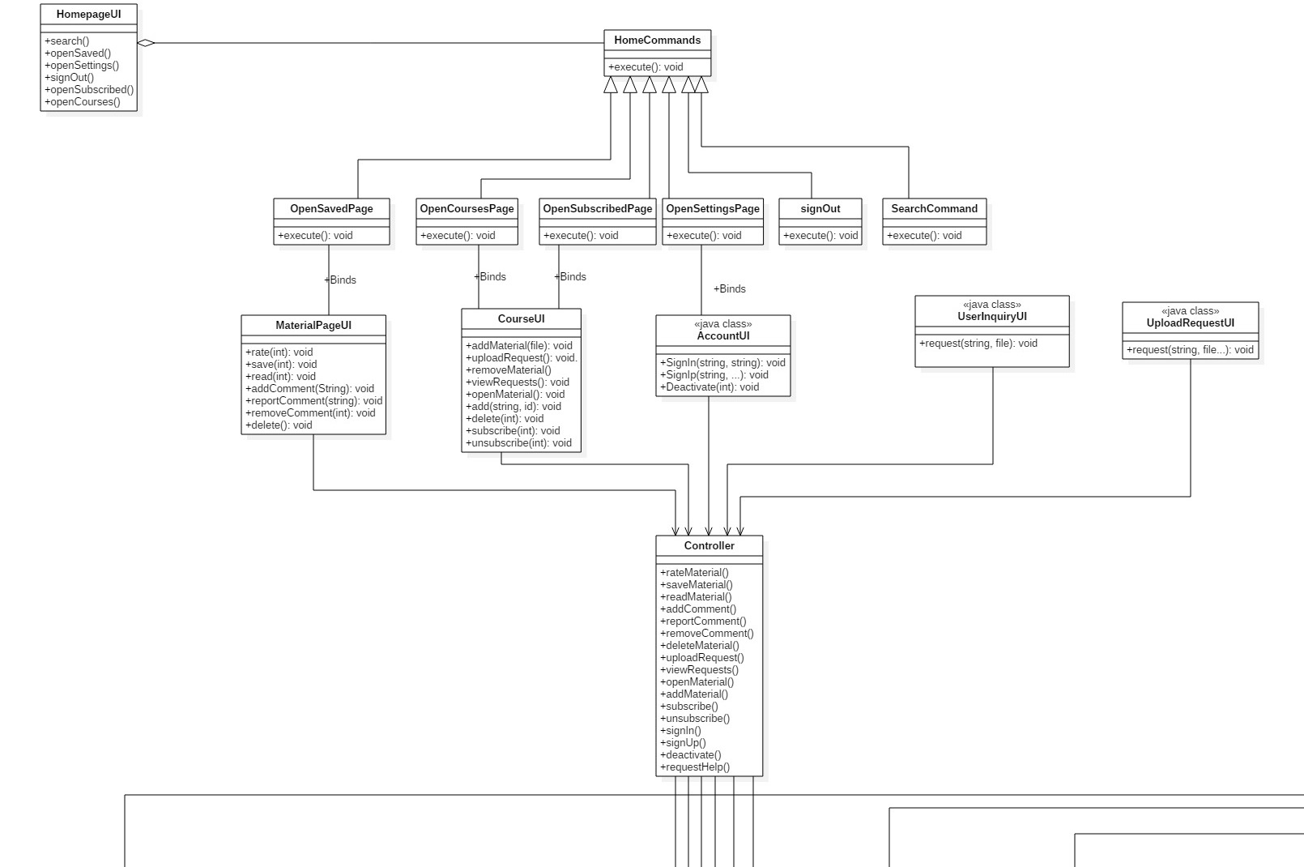

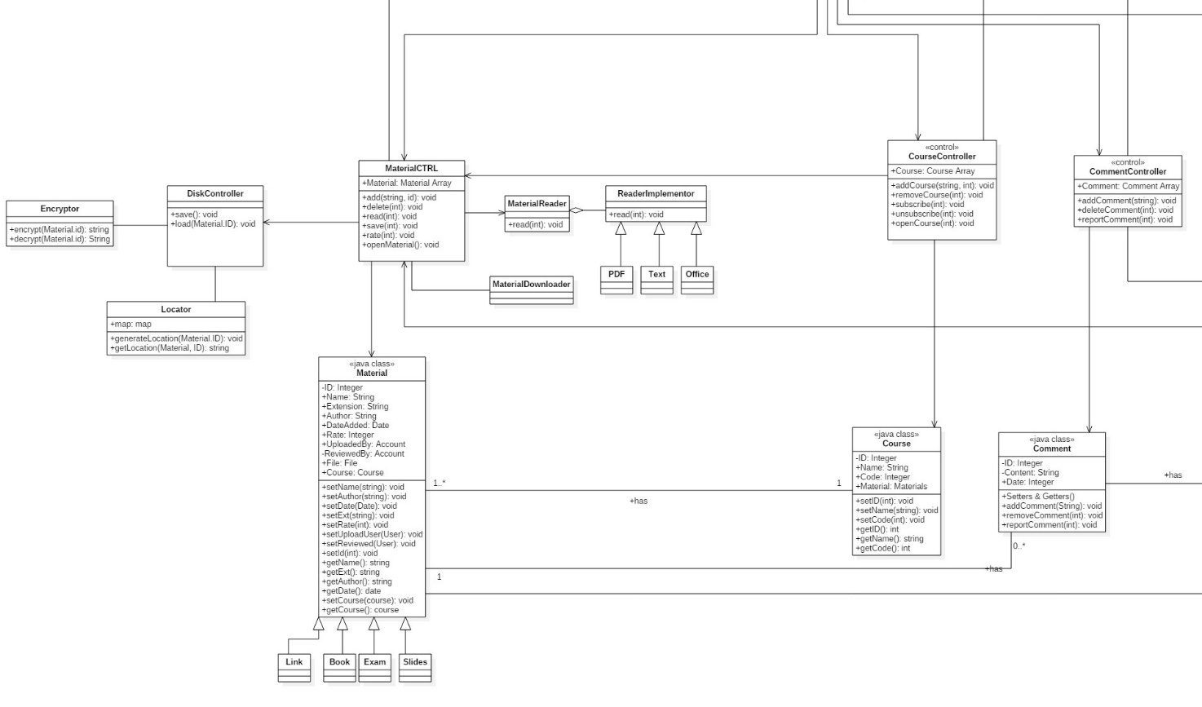

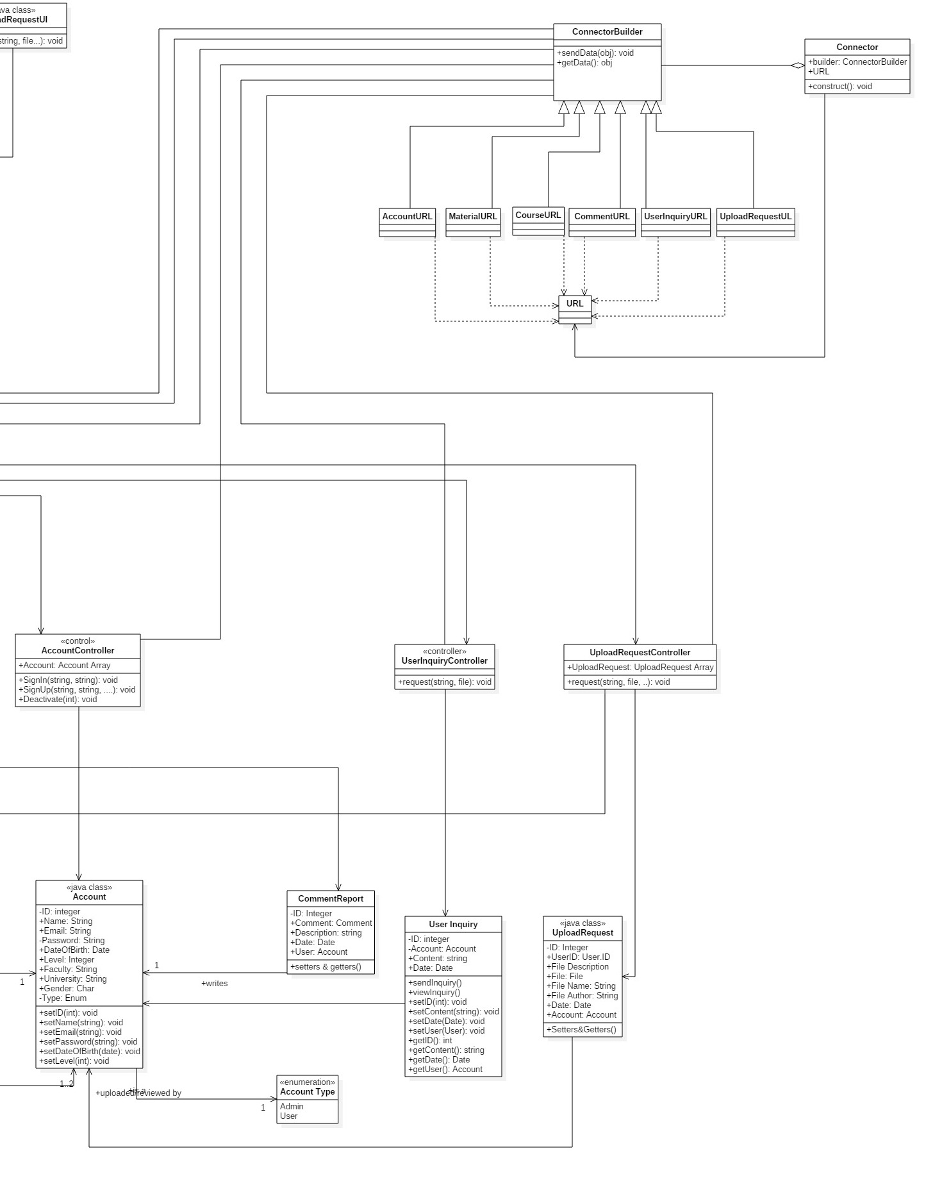

**List down your classes and describe them**

| **Class ID** | **Class Name** | **Subsystem ID** | **Description & Responsibility** |
| --- | --- | --- | --- |
|  | HomePageUI |  |  |
|  | HomeCommand |  |  |
|  | SavedPage |  |  |
|  | CoursesPage |  |  |
|  | SubscribedPage |  |  |
|  | SettingsPage |  |  |
|  | SignOut |  |  |
|  | Search |  |  |
|  | MaterialUI |  |  |
|  | CourseUI |  |  |
|  | AccountUI |  |  |
|  | UserInquiryUI |  |  |
|  | UploadRequestUI |  |  |
|  | Controller |  |  |
|  | MaterialCTRL |  |  |
|  |  |  |  |
|  |  |  |  |
|  |  |  |  |
|  |  |  |  |

* **In the above table make sure that each class belongs to a subsystem.**
* **In the above table ALL classes should belong to subsystems. And each subsystem should at least contain one class.**

### Important Algorithm

* **If any method in a class is implementing an algorithm (complex enough), then you should describe it here.**

## III. Sequence diagrams

* **List Sequence diagrams for all requirements. Provide for each Sequence an ID.**
* **Usually each use case is represented by a sequence diagram or more.**
* **Overall, all the diagrams should represent all requirements and possible flows.**
* **Make sure that each object in the sequence diagram has a corresponding class in the class description table above. If not, it will be REJECTED.**
* **Put actual function calls with proper parameters and return types corresponding to class diagrams.**
* **Following are couple of examples for small / meduim examples. We expect such diagrams, however there is a missing thing in them. Most of calls don’t have parameters. Please always specify the parameters in the call, matching the class diagram.**

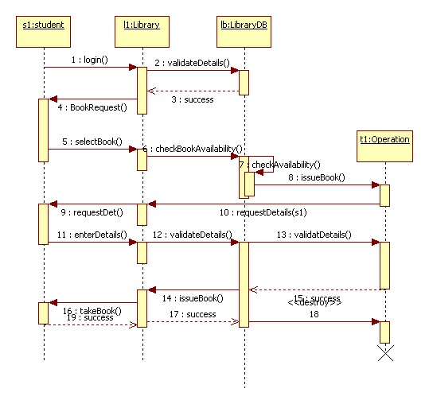

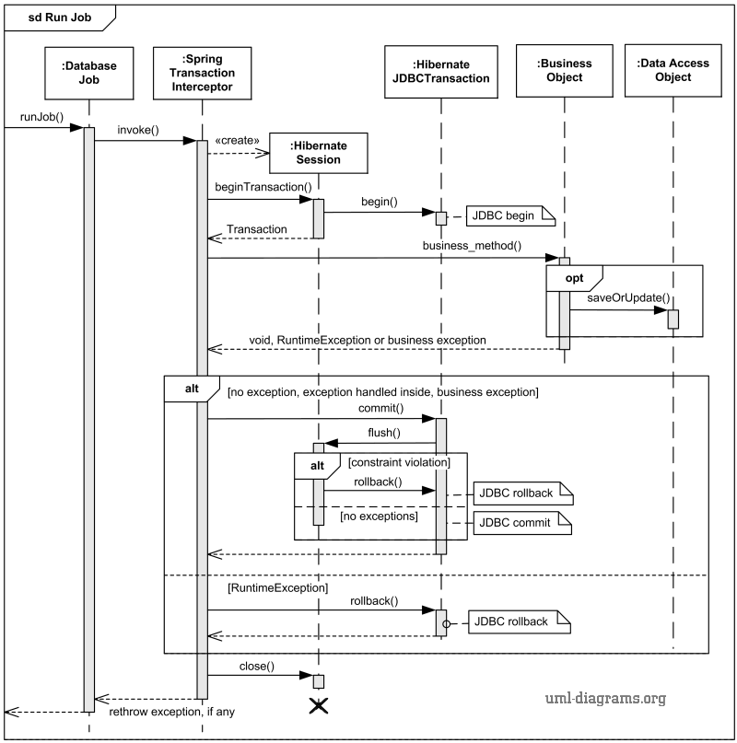

### Class - Sequence Usage Table

* **In this table, we will list EVERY class in class diagram and which sequences used this class diagram. This helps in avoiding either unused classes or extra classes appears in sequence diagrams. In "Overall used methods" section, put all functions appeared in all sequences. If this table was built in ignorance of actual class / sequence diagrams = REJECTED for whole document.**

| **Class Name** | **Sequence Diagrams** | **Overall used methods** |
| --- | --- | --- |
| E.g. Employee | 1, 3, 5 (means Seq Ids 1, 3, 5 used Employee class) | Save, GetData |
|  |  |  |

## IV. Physical Entity-Relationship Diagram

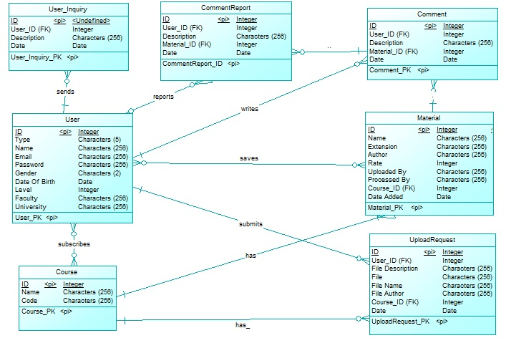

## 

## V. User Interface Design

* **Screen 1 – Login Screen**

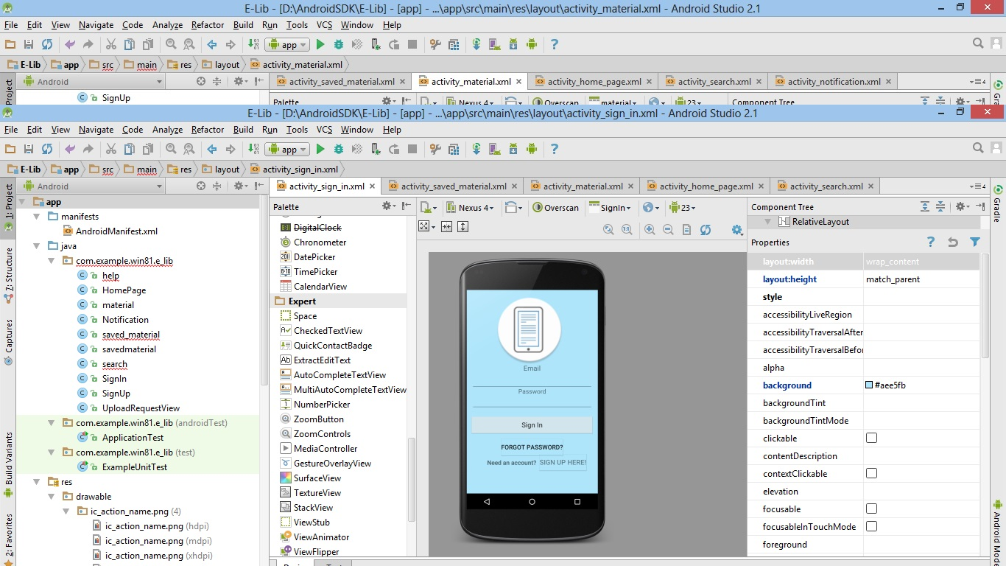

* **Screen 2 – Home Page**

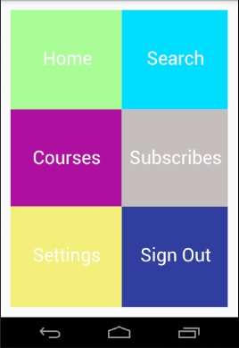

* **Navigation tree: Login Screen**

**|**

* **Navigation tree: HomePage**

**Screen 3 – Sign up**

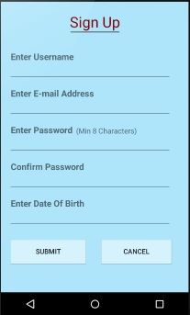

* **Navigation tree: Login Screen**

**|**

* **Navigation tree: SignUp**

**Screen 4 – Notification Page**

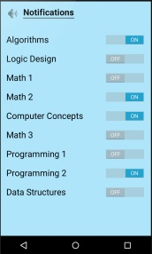

* **Navigation tree: Login Screen**

**|**

* **Navigation tree: HomePage**

**|**

* **Navigation tree: Settings**

**|**

* **Navigation tree: Notification Settings**

**Screen 5 – Material Page**

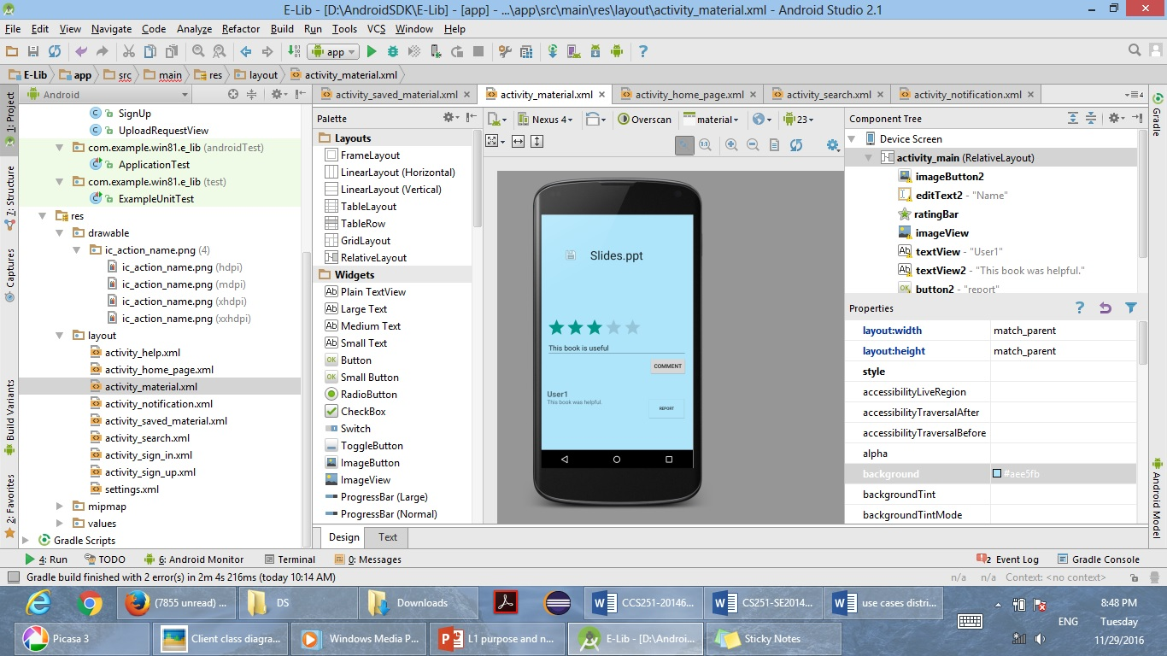

* **Navigation tree: 1) Login Screen**

**|**

* **Navigation tree: HomePage**

**|**

* **Navigation tree: Courses**

**|**

* **Navigation tree: Material**
* **2) Login Screen**

**|**

* **Navigation tree: HomePage**

**|**

* **Navigation tree: Saved**

**|**

* **Navigation tree: Material**

**Screen 6 – View Requests List**

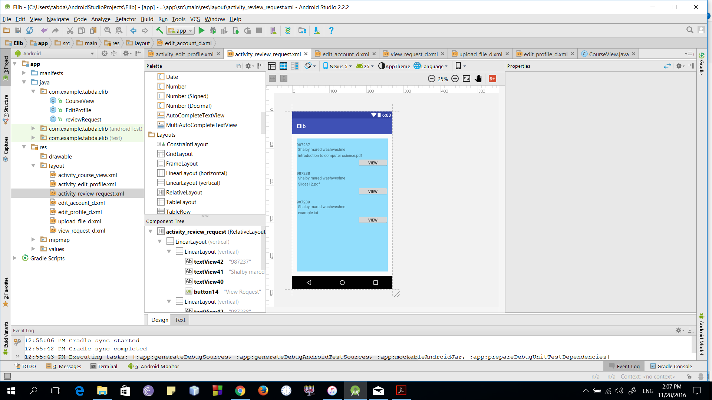

* **Navigation tree: Login Screen**

**|**

* **Navigation tree: HomePage**

**|**

* **Navigation tree: Courses**

**|**

* **Navigation tree: View Requests List**

**Screen 6 – View Request**

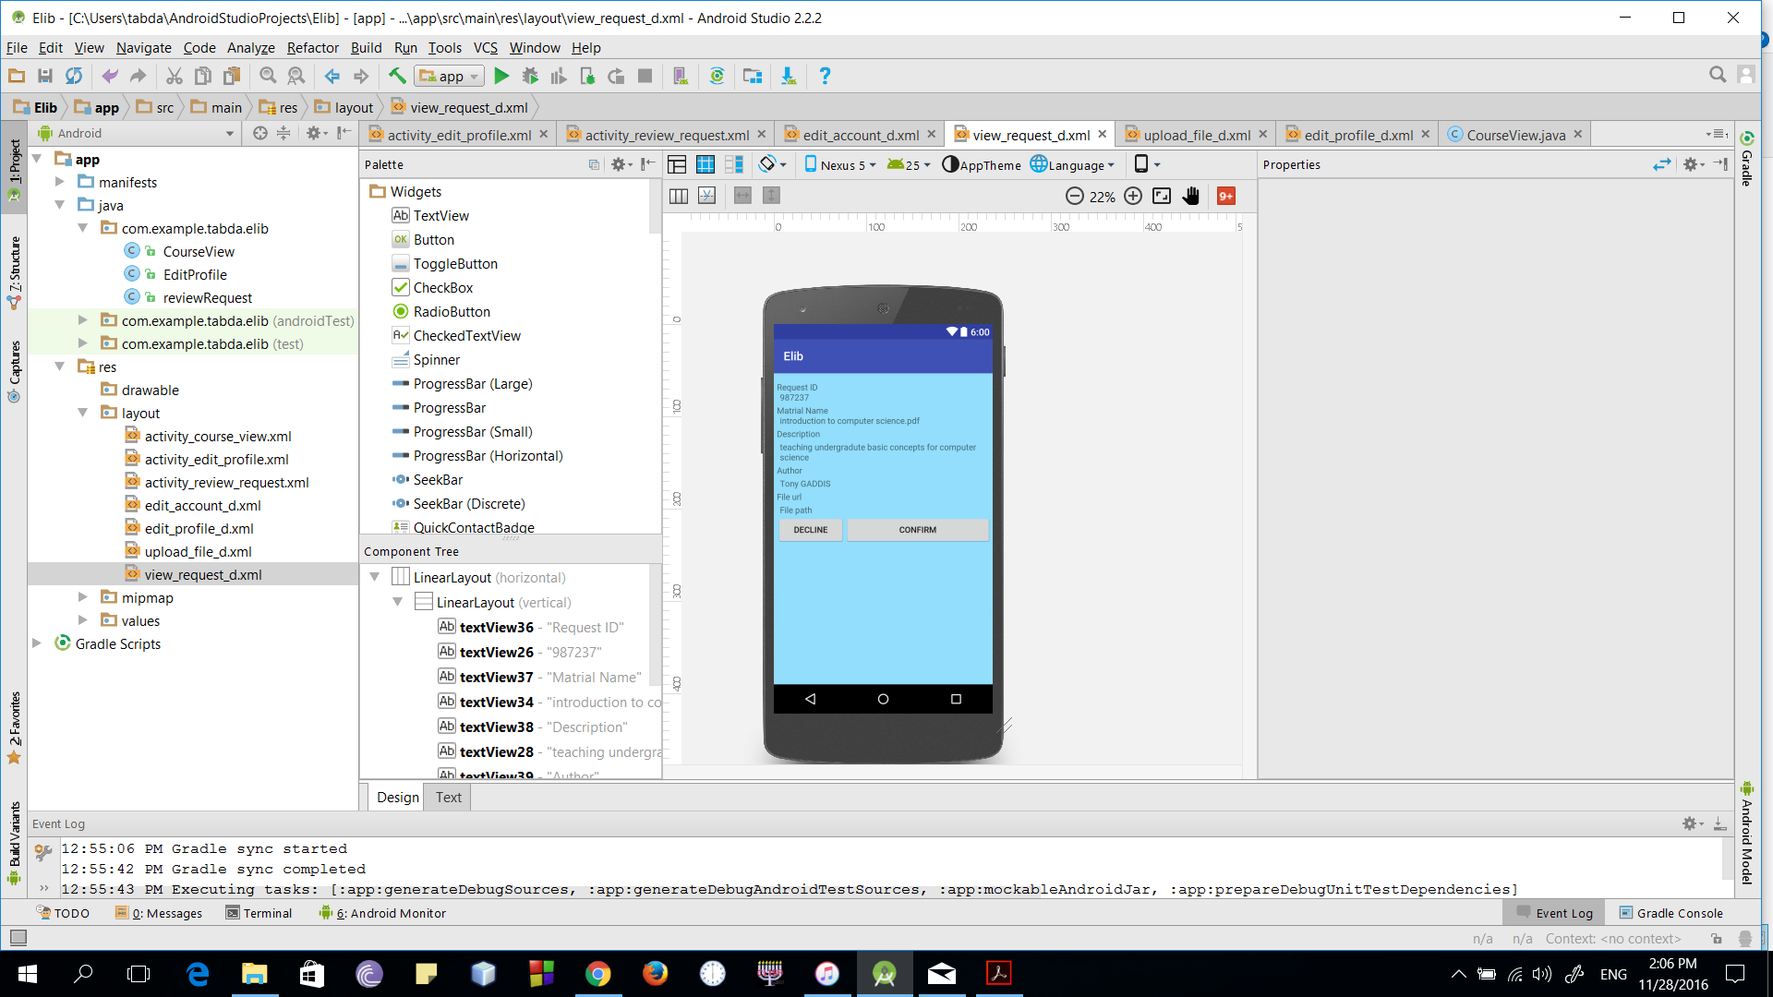

* **Navigation tree: Login Screen**

**|**

* **Navigation tree: HomePage**

**|**

* **Navigation tree: Courses**

**|**

* **Navigation tree: View Requests List**

**|**

* **Navigation tree: View Request**

**Screen 8 – Upload Request**

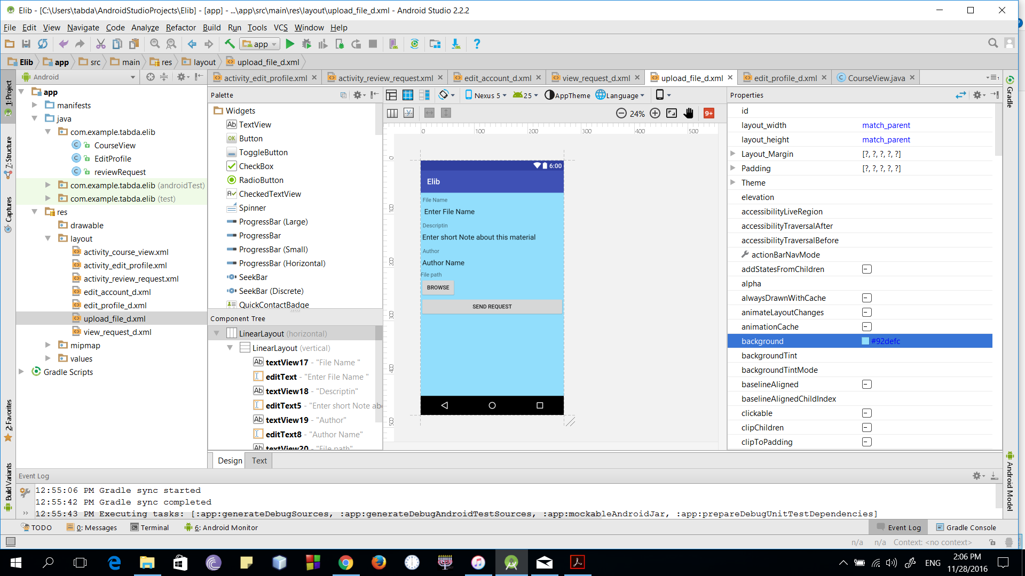

* **Navigation tree: Login Screen**

**|**

* **Navigation tree: HomePage**

**|**

* **Navigation tree: Courses**

**|**

* **Navigation tree: Upload Request**

**Screen 9 – Edit Profile**

* 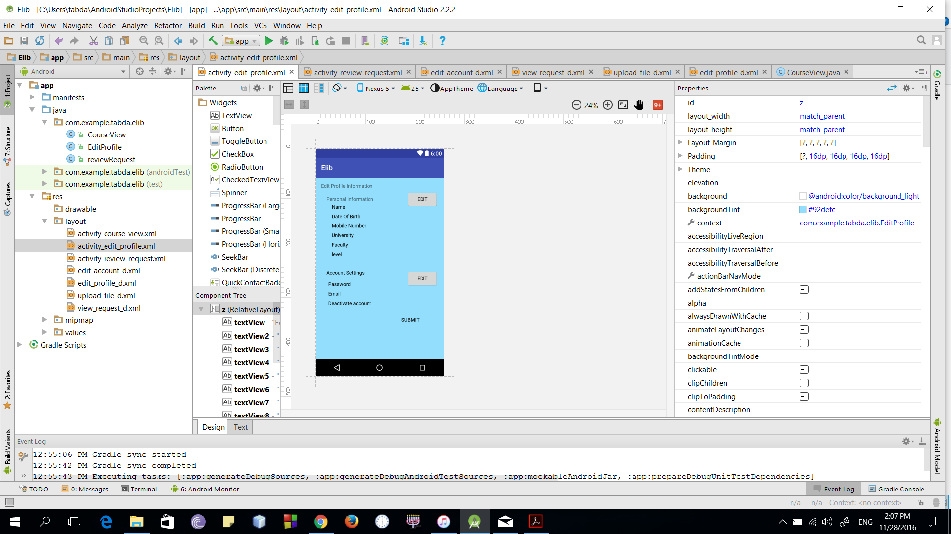
* **Navigation tree: Login Screen**

**|**

* **Navigation tree: HomePage**

**|**

* **Navigation tree: Settings**

**|**

* **Navigation tree: Edit Profile**

**Screen 10 – Edit Personal Information**

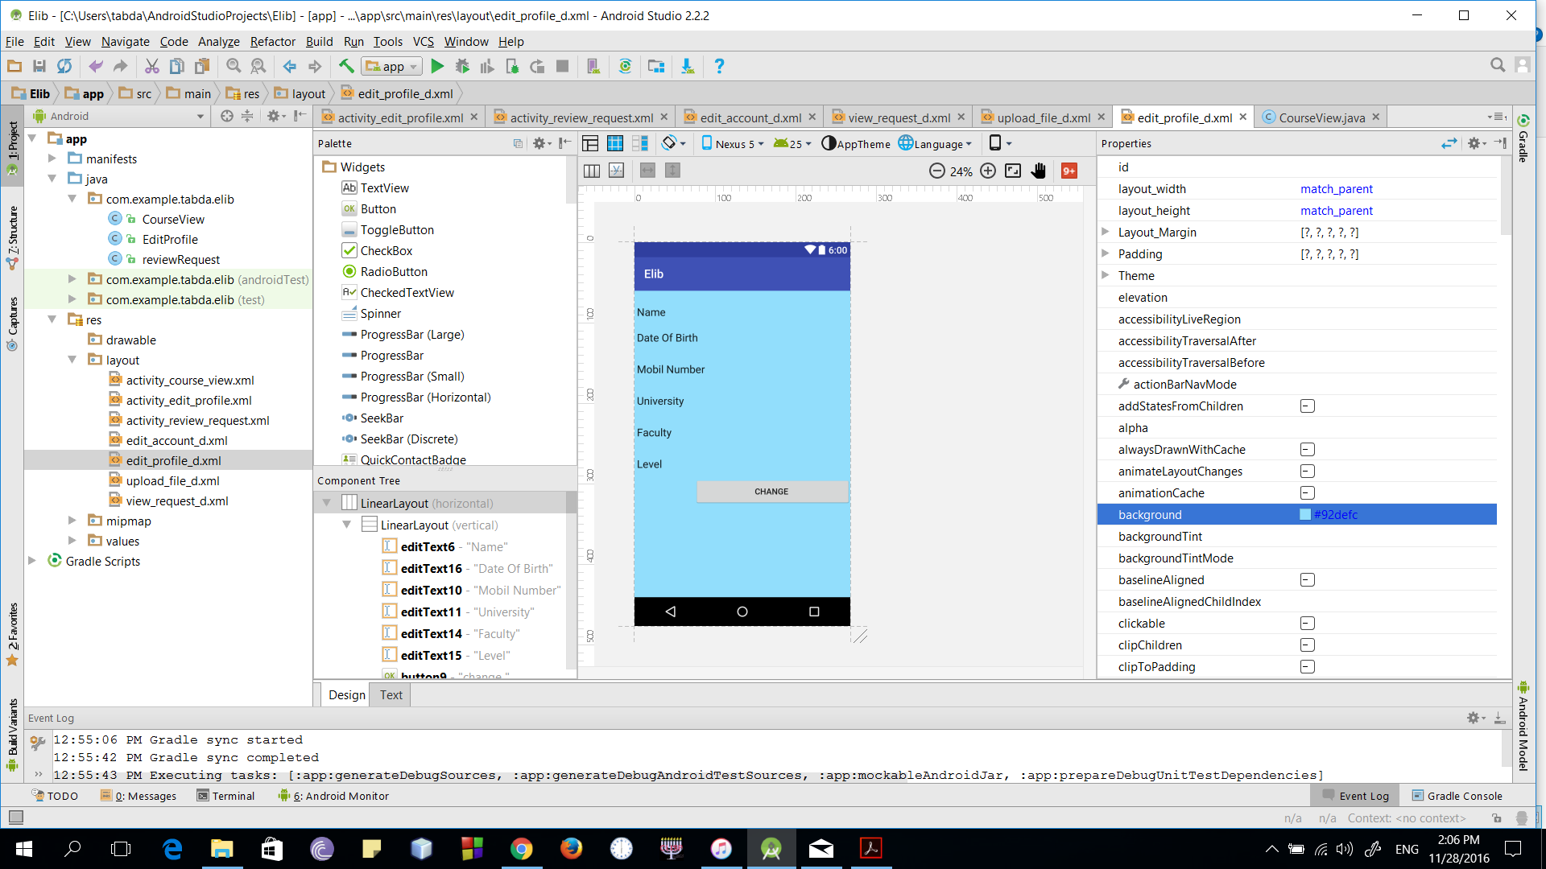

* **Navigation tree: Login Screen**

**|**

* **Navigation tree: HomePage**

**|**

* **Navigation tree: Settings**

**|**

* **Navigation tree: Edit Profile**

**|**

* **Navigation tree: Edit Personal Information**

**Screen 11 – Edit Account Information**

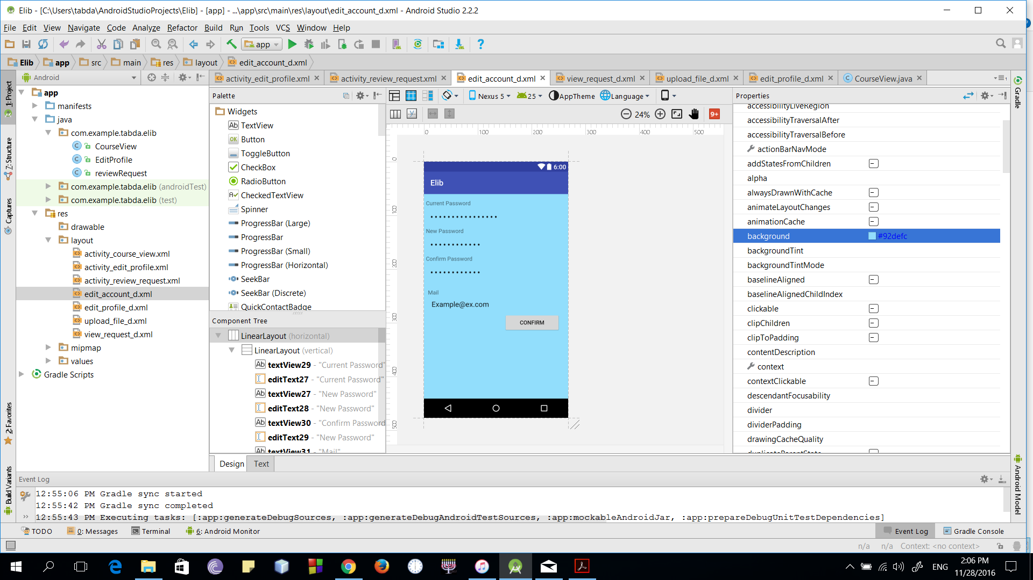

* **Navigation tree: Login Screen**

**|**

* **Navigation tree: HomePage**

**|**

* **Navigation tree: Settings**

**|**

* **Navigation tree: Edit Profile**

**|**

* **Navigation tree: Edit Account Information**

**Screen 12 – Course Page**

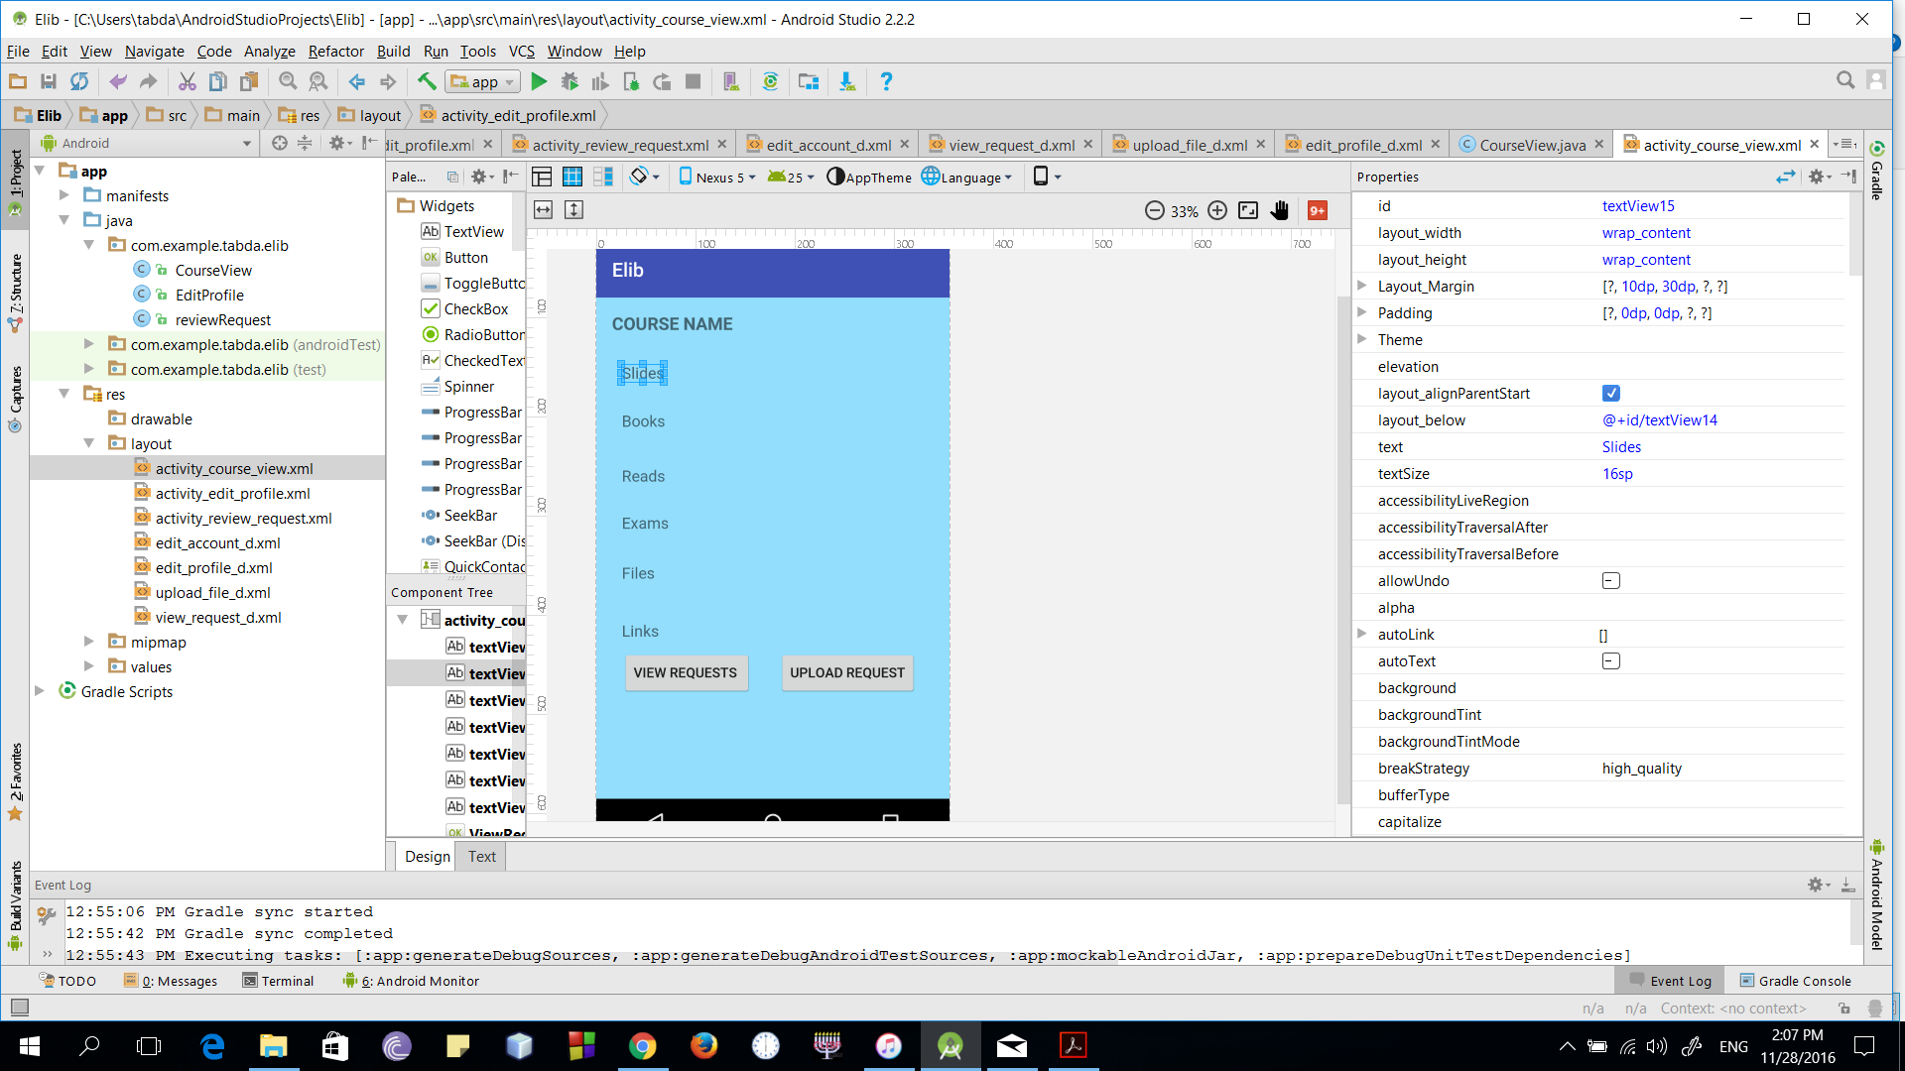

* **Navigation tree: Login Screen**

**|**

* **Navigation tree: HomePage**

**|**

* **Navigation tree: Courses**

**|**

* **Navigation tree: View Course**

**Screen 13 – Saved Material**

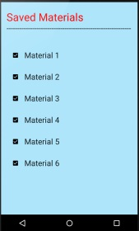

* **Navigation tree: Login Screen**

**|**

* **Navigation tree: HomePage**

**|**

* **Navigation tree: Saved**

**Screen 14 – Settings**

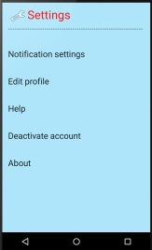**Nn tree:**

* **Navigation tree: Login Screen**

**|**

* **Navigation tree: HomePage**

**|**

* **Navigation tree: Settings**

**Screen 15 – Search**

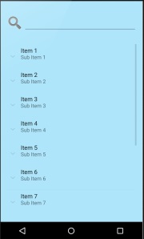

* **Navigation tree: Login Screen**

**|**

* **Navigation tree: HomePage**

**|**

* **Navigation tree: Search**

**Screen 16 – Help**

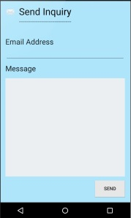

* **Navigation tree: Login Screen**

**|**

* **Navigation tree: Settings**

**|**

* **Navigation tree: Help**

## VI. Bonus: State Diagram and OCL

* **Choose a non-trivial entity that has different states and develop a state diagram for it.**
* **Choose 5 functional requirements that cannot be represented by class and sequence diagrams and develop OCL constraints for them.**

# Ownership Report

|  |  |
| --- | --- |
| **Item** | **Owners** |
|  |  |
|  |  |

# References

* http://www.mhhe.com/engcs/compsci/pressman/graphics/Pressman5sepa/common/cs1/design.pdf

# Authors

* Mostafa Saad and Mohammad El-Ramly